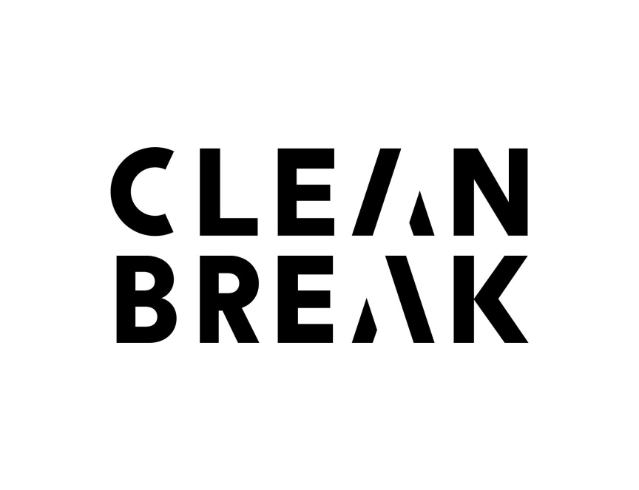

**Catering Volunteer (Women only)**

|  |  |
| --- | --- |
| Organisation Name | Clean Break Theatre Company |
| Organisation Overview | Clean Break provides theatre and writing based opportunities, including workshops from our studios in Kentish Town NW5 for women who have lived experience through the criminal justice system or women at risk of entering it due to drug/alcohol and/or mental health needs. We work in a safe, women-only environment, creating opportunities for women to develop personal, social, artistic and professional skills. |
| Directions | Buses: 46, 88, 134, 214, 393 Tube: Kentish Town (Northern Line) – Kentish Town station is closed for 1 year. Overground: Kentish Town West |
| Role Title | Catering Volunteer |
| Responsible to | Members Support Manager and Volunteer Manager |
| Purpose/Summary of role | We are looking for enthusiastic volunteers to be a part of the Catering Team. To assist with the preparation and service of nutritious food to our Members, maintaining Health & Safety and kitchen hygiene standards |
| Description of tasks | Food Preparation – catering for daily lunches and internal and events, tasks include prepping, cooking, dishing up and serving, washing up and clearing up kitchen. Ingredients will be cooked, from fresh, frozen, or tinned stock to create healthy meat and vegetarian/vegan dishes. To assist with periodic intensive cleaning of the catering space. |
| Time Commitment | 3 months with end of season review to continue.  Flexible one day a week either on:  Mondays 10-2.30pm or Wednesdays 10-2.30pm |
| Skills and Qualifications | This role would suit someone who enjoys cooking and working as part of a team. A basic level of cooking knowledge and ability to follow instruction is essential.  Some experience or a desire to work with vulnerable women who have been through the criminal justice system or at risk of entering it. Desirable that candidate is locally based  Friendly, efficient, reliable, able to take initiative. |
| Disabled Access | Yes – Wheelchair accessible |
| Training and Induction | Yes – induction, ongoing support and training will be provided.   * Food and Hygiene Level 2 qualification **must** be undertaken or updated within 1 month of taking on role, provided by Clean Break.   Food Standards Agency: Safer Food Better Business for Caterers:   * Food Allergen * Open Checks and Closing Checks * Temperature control and readings, * Food labelling * Food handling and Transport * Cross-contamination of foods * Occupational Health * Cleaning * Supervision |
| Expenses | Yes – Travel and lunch |
| Recruitment Method | CV, informal discussion, reference, trial period, Basic DBS   * The post is open to women only   (an exception under the Equality Act 2010 Schedule 9, Part 1). |
| Contact information | Samantha McNeil – Volunteer Manager 2 Patshull Road  Kentish Town  London  NW5 2LB  Tel: 020 7 482 8621 Email: [samantha.mcneil@cleanbreak.org.uk](mailto:samantha.mcneil@cleanbreak.org.uk)  Email: [volunteering@cleanbreak.org.uk](mailto:volunteering@cleanbreak.org.uk)  Web: www.cleanbreak.org.uk |